M1 – L22 – Solving Systems Algebraically

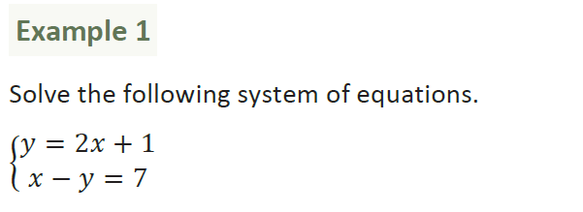

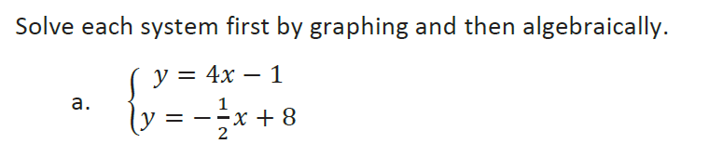

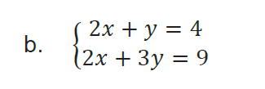

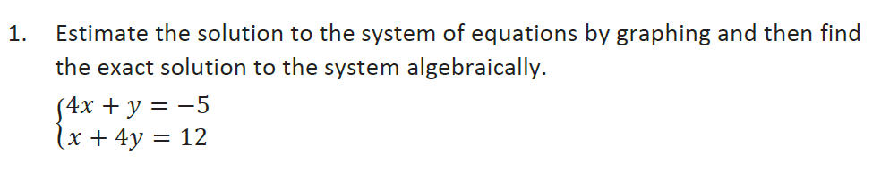

3. Jack bought 3 slices of cheese pizza and 4 slices of mushroom pizza for a total cost of $12.50. Grace bought 3 slices of cheese pizza and 2 slices of mushroom pizza for a total cost of $8.50. What is the cost of one slice of each pizza?

Let _____ = ______________________

Let _____ = ______________________

Equation #1:______________________

Equation #2: _____________________

slice of mushroom pizza: _________

slice of cheese pizza: ____________

4. The sum of two numbers is 47, and their difference is 15. What is the value of each number?

Let _____ = ______________________

Let _____ = ______________________

Equation #1:______________________

Equation #2: _____________________

Number 1: ___________

Number 2: ___________
5. The cost of 3 markers and 2 pencils is $1.80. The cost of 4 markers and 6 pencils is $2.90. What is the cost of each item? Include appropriate units in your answer.

Let _____ = ______________________

Let _____ = ______________________

Equation #1: ______________________

Equation #2: ______________________

one marker:____________

one pencil: _____________
6. The total score in a football game was 72 points. The winning team scored 12 points more than the losing team. How many points did each team score?

Let _____ = ______________________

Let _____ = ______________________

Equation #1:______________________

Equation #2: _____________________

winning team points:____________

losing team points: _____________

